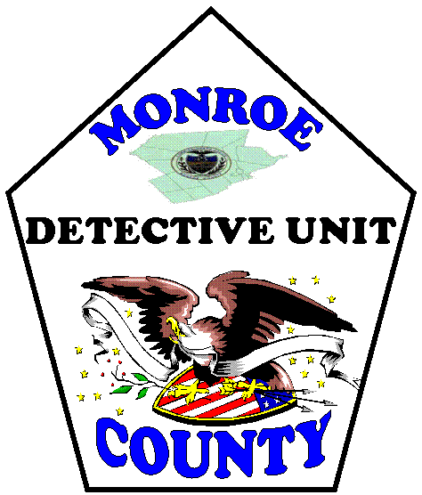
MONROE COUNTY OFFICE OF THE DISTRICT ATTORNEY
INTERNSHIP APPLICATION

E. David Christine, Jr.
District Attorney

Applicant Information
First Name |  | MI |  | Last Name |  |  | Social Security Number |  | Date of Birth
House No. | Street Name |  |  |  | City |  |  | State | Zip
Home Telephone Number |  |  | Cell Phone Number |  |  | Email Address

College/University Information
College or University | Mailing Address
Name of Practicum Coordinator/Counselor/Advisor | Telephone Number | Email Address
Major/Degree Program |  | GPA | Current Year in School

Internship Preference – select one
District Attorney Detectives Unit District Attorney Prosecutors Office

Include the following with this application:
- Letter of Interest – describe your qualifications for and interest in the internship to which you have applied.
- Resume or Curriculum Vitae
- Two letters of recommendation (one must be from a current professor). Letter may be emailed directly from the recommender’s email account or mailed in a sealed envelope with the recommender’s signature across the flap.
- Your most recent academic transcript (official or unofficial).

How did you hear about our internship program?

By submitting this application and signing the attached documents you authorize that a background investigation be completed by the Monroe County Office of the District Attorney. A background investigation may include, but is not limited to, a criminal records check, a driver history records check, and a civil records check.

Send application material to:
Chief County Detective Eric J. Kerchner
Monroe County Office of the District Attorney
610 Monroe St – Ste 126
Stroudsburg PA 18360

Materials may be emailed as a pdf to ekerchner@co.monroe.pa.us

